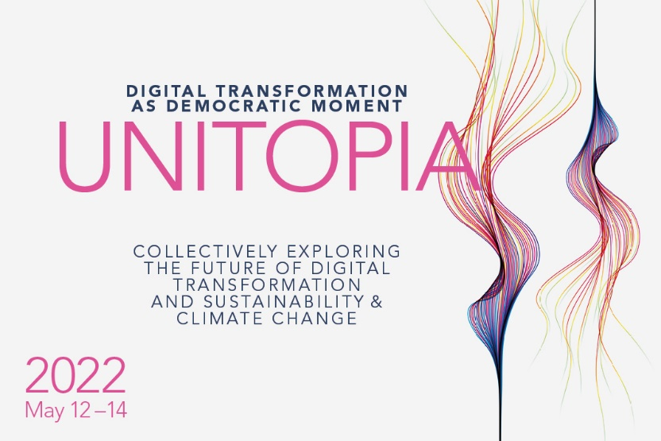
Please rename the file with Call for Papers_UNITOPIA2022_Name_Title.
Submit the document as .doc file and do NOT convert it to PDF. Thank you!

Digital Transformation as Democratic Moment: Call for Papers

Abstract Submission
Track  (please choose one) | PARTICIPATION IN TECHNOLOGY DESIGN & VALUES /  DIGITAL INFRASTRUCTURES & DEMOCRACY /  ENVISIONING THE FUTURE AND POLICY OF DIGITAL TRANSFORMATION
Author Name(s) & Affiliation(s)
ARQUS Alliance member | YES / NO
Abstract Title
Abstract (max. 500 words)

